Govt. Polytechnic College Bhikhiwind



PROJECT SYNOPSIS OF HOTEL RESERVATION MANAGEMENT

COMPUTER ENGINEERING

IN

6th SEMESTER

SUBMITTED TO: SUBMITTED BY:
Mr. Amarjit Singh Inderbir Singh
Lect. Comp. Engg Reg.no.206026

TABLE OF CONTENTS

Sr. no. | NAME
1. | Overview of project
2. | Abstract of project
3. | About of project
4. | Scope of future
5. | Working on project
6. | Conclusion

OVERVIEW OF PROJECT

MY PROJECT NAME IS:-

Computer shop

Hotel Reservation Management System is wide-ranging software suite incorporate of integrated modules for various features of hotel management. Hotel reservation System has all the features required to run your hotel, motel and guest house business. Hotel Reservation Management System offers an operational integration between reservations, guest history, reception/ front desk, Sales Ledger, Accounting and Reporting modules. Hotel reservation System is a system designed to simplify the booking process and allow you to get on with running your business. You can analyze the booking, reservation, check in & checkout trends and work towards your forthcoming future requirements. Managing replication of customer records and records their comments on hospitality. Make food allergy notes, record special events and birth dates. Make your customers feel unique and special by recording personal notes. Hotel & motel Reservation software is a program designed to manage daily booking or checking checkouts of guesthouse or hotel rooms. It uses a MS Access database on backend database. Reservations can be assigned to user defined rooms or sweets. Main Features: • Customize Hotel rooms with prices. • Save the client's information into the database prior to Booking or Check in for any forthcoming use. • Reservation for the customer for specific date with advance payment insertions. • Check in for the specified duration & room will appear engaged for the duration. • Checkout hotel after complete payment insertion. Operational Advantages: • Every single instance you make a reservation, the room status is modified and the customer details are added to your hotel database. • Use the once entered records for life time for the repeated customers. • Better option for expensive Customer Relations.

The modern hotel and tourism industry is now approaching a crucial stage in development-in some way is facing its own mid-life crisis. THE HOTEL MANAGEMENT AND TOURISM attempts to offer a more comprehensive examination of tourism and hospitality growth and development, a new perspective for its systematic approach to planning and management and a synoptic summary of individualized impacts of tourism-economic, environmental, cultural and ecological. This supremely practical, prescriptive and informative encyclopaedia provides a rare insight into the realities of hospitality, hotel and catering management highlighting its managerial, economic, financial, behavioural and human resource problems and prospects. The encyclopaedia is a systematic approach to the hotel and tourism industry, which review its individual components in a more justified and simplified technique. The encyclopaedia is particularly useful to the student of hotel management and tourism, practitioners of the industry, research community and those involved with the development and planning of the industry. Its readable and lively style makes it suitable for diploma and degree courses of tourism, hotel and catering management as well as reference work for the institutions, research organizations and leisure development bodies.s

ABSTRACT

In the reservation of hotel room is a challenging job, to keep record of customer and a room is a crucial task to be completed. This can be easily performed by using this software. The following activities can be performed using this software:-

- Reserving room
- Checking room status whether the room is available or not.
- Modifying any data or customer record if necessary.
- Deleting any record if it is outlives its utility.
- Quitting the project

ABOUT THE PROJECT

In the reservation of hotel room is a challenging job, to keep record of customer and rooms are a crucial task to be completed. This can be easily performed by using this software. A room reservation whether is single or double it is very easy to reserve it. Checking room status whether the room is available or not. Modifying any data or customer record if necessary. Deleting any record if it is outlives its utility.

SCOPE IN FUTURE

In the reservation of hotel room is a challenging job, to keep record of customer and rooms are a crucial task to be completed. This can be easily performed by using this software. The following activities can be performed using this software:-

- Reserving room
- Checking room status whether the room is available or not.
- Modifying any data or customer record if necessary.
- Deleting any record if it is outlives it’s utility.
- Quitting the project

Working on project

Step 1
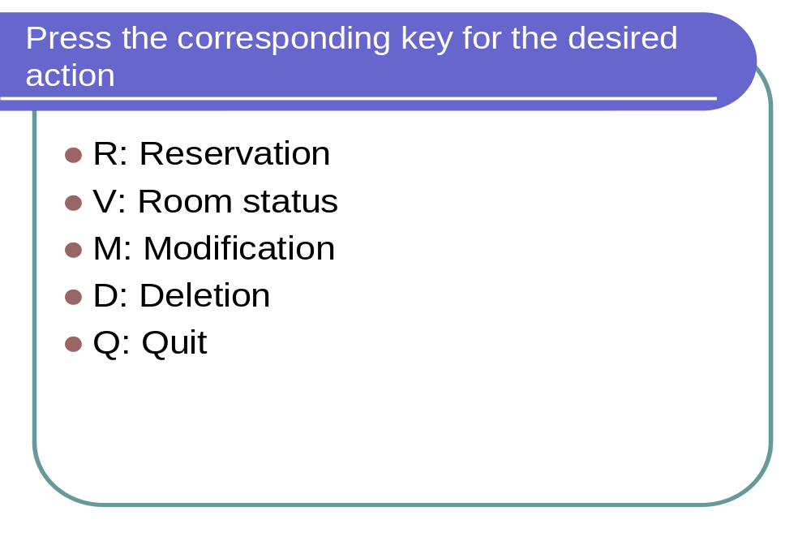Step 2

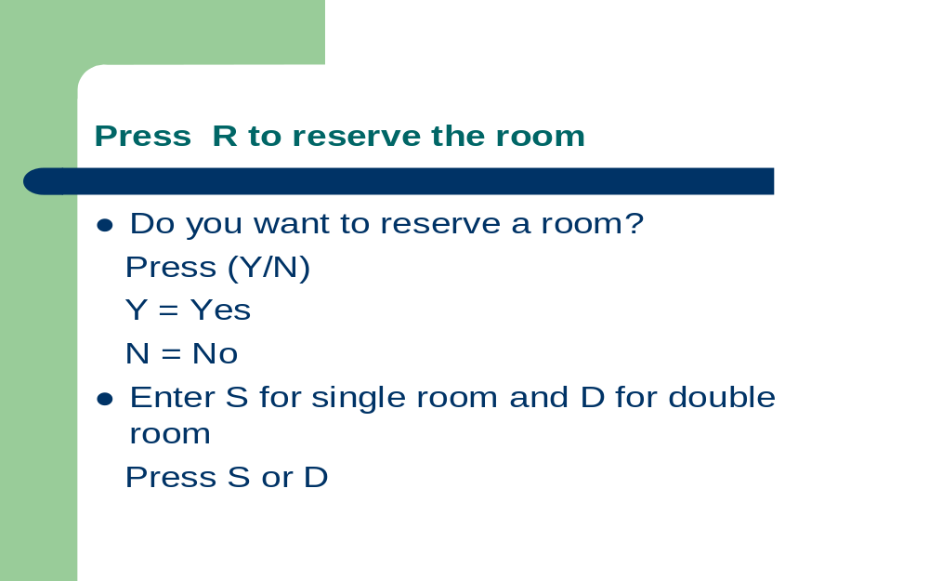
Step 3
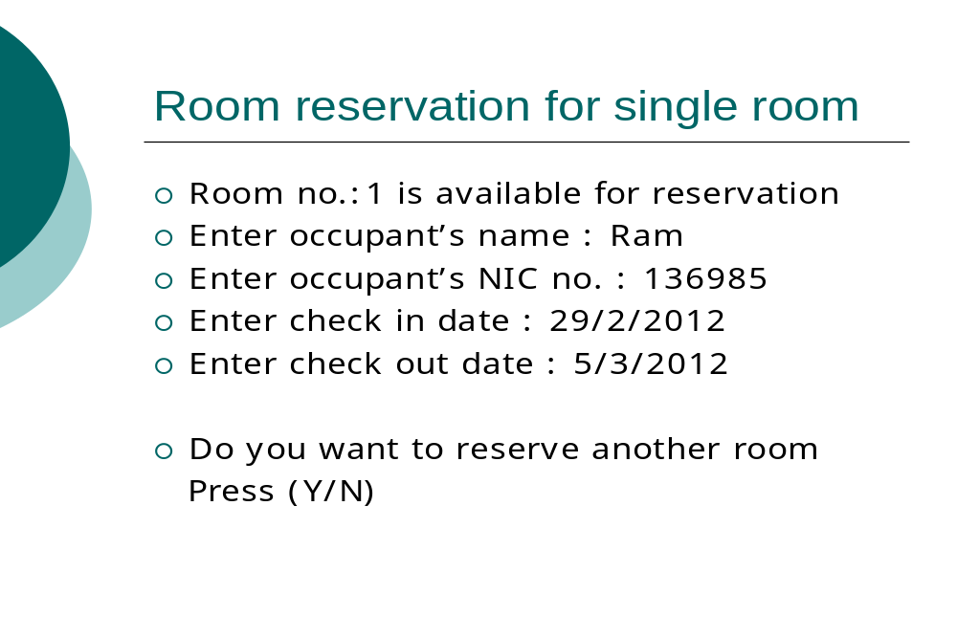Step 4
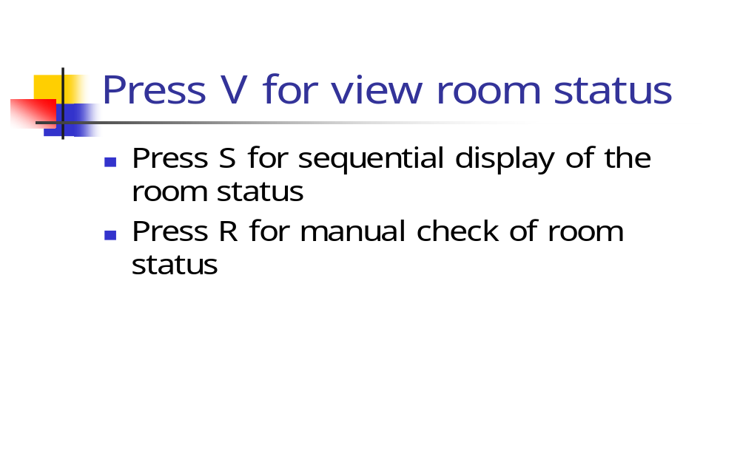
Step 5
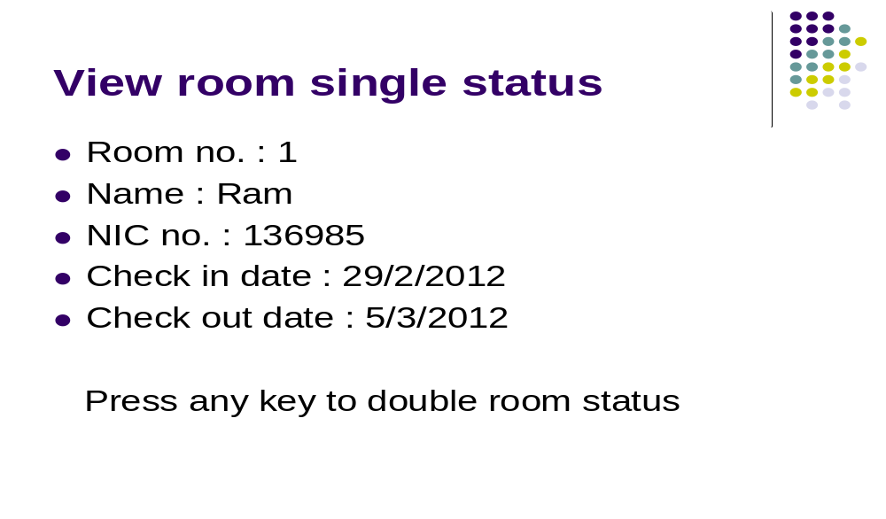Step 6
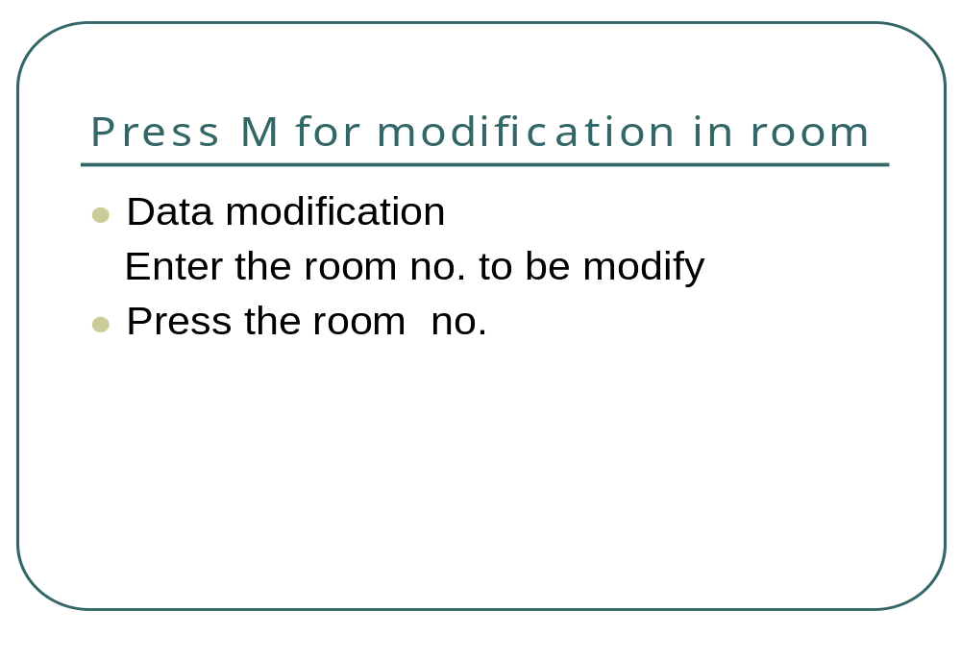
Step 7
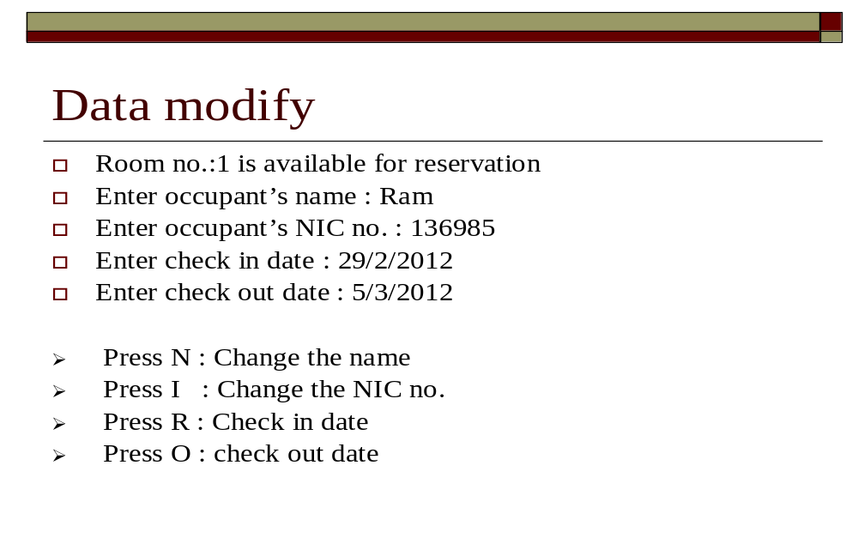Step 8
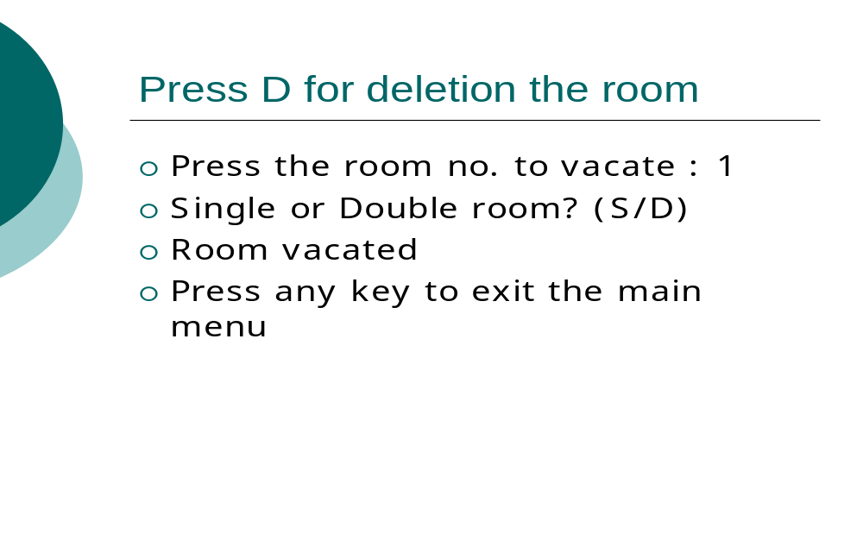
Step 9



CONCLUSION

Computerization of hotel in booking system is very must because otherwise it becomes very difficult for the cure to manage a big hotel this program will bring a revolution in this field. Rooms reservation whether is single or double it is very easy to reserve it. Checking room status whether the room is available or not. Modifying any data or customer record if necessary. Deleting any record if it is outlives it’s utility.

